**Creative Brief**

Lucy Chen

11/13/2019

**Project Title: History of Printing in East Asia**

1. Project overview

The goal is to be informational since not many people know about Asian art or historic printing. I want to show printing of words/literature as well as art images.

1. Resources

Copy found <https://en.wikipedia.org/wiki/History_of_printing_in_East_Asia> as well as images of printed works from Google or anywhere.

1. Audience

Audience is people who don’t know much about Asian art – more of an introductory site for students or anyone that wishes to learn more.

1. Message

I want to focus on how printing in Asia was just as advanced as it was in the west. I want there to be focus on printing words/books not just images and how there are different challenges with Asian character systems.

1. Tone

The tone should be simple and educational. There shouldn’t be any attempt to make the page seem oriental but more of an international style (think Asian-minimalist Marie Kondo style). You can add some flourishes and swashes, but I think keep it less busy.

1. Visual Style

I’m thinking more minimalistic so that there is more emphasis on the images. Maybe specific words within the text can be highlighted in some way so that the audience can do a quick read and easily access the information. Also maybe a spot color can be added that potentially changes across different pages of the website. I’m thinking also some fixed elements and some not fixed?

Here are some ideas and inspirations

<http://www.mgmtdesign.com/>

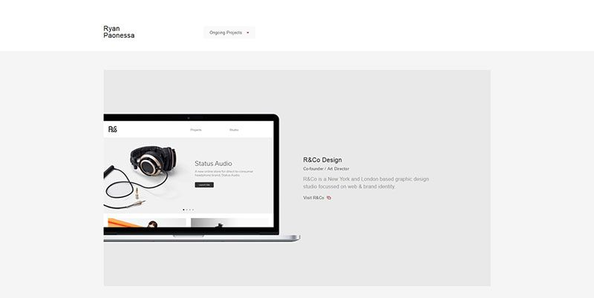

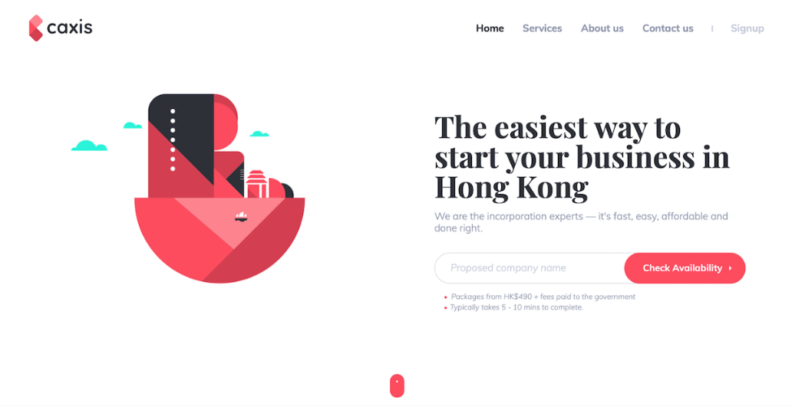

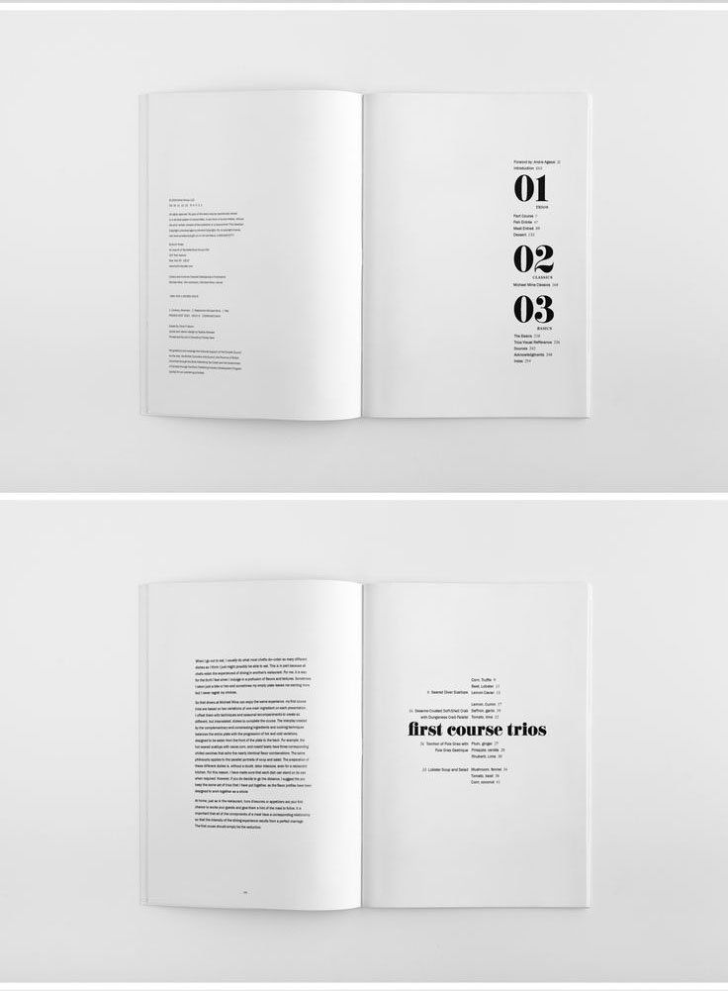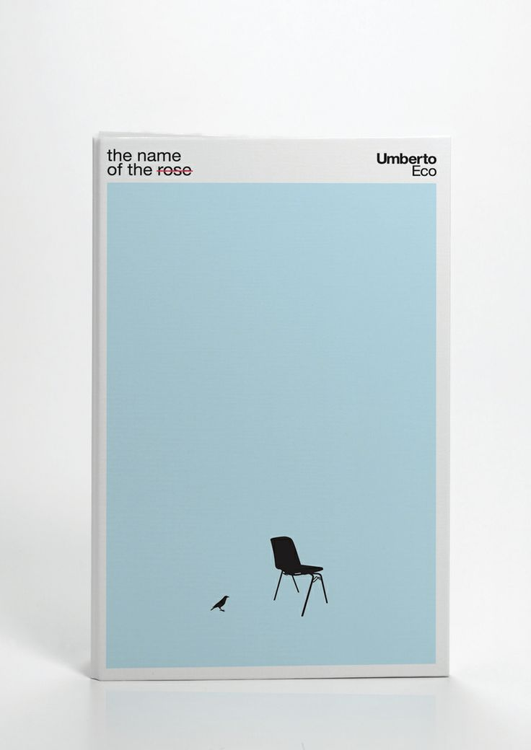

Let me know if you have any questions or anything